**CSA1518-CLOUD COMPUTING**

V.Mrudula

192011395

**Expt:08**

Create a Virtual Hard Disk and allocate the storage using VM ware Workstation

**IMPLEMENTATION:**

STEP 1: DOWNLOAD VMWARE WORKSTATION AND INSTALLED AS TYPE 2 HYPERVISOR

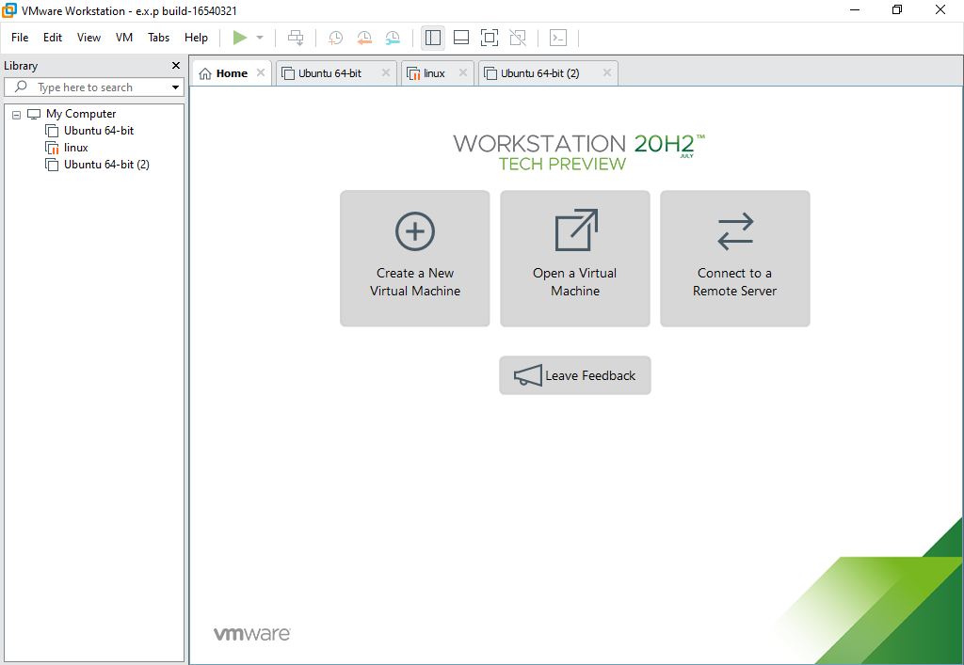

STEP 2: GO TO FILE AND SELECT NEW VIRTUAL MACHINE

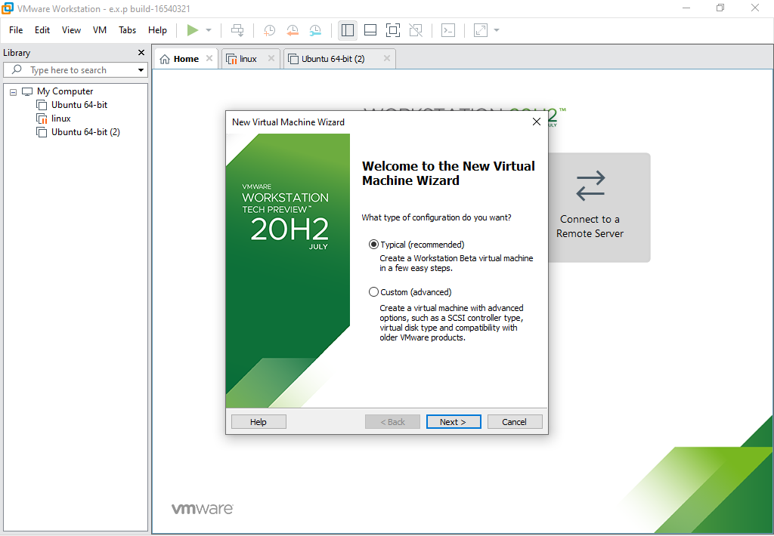

STEP 3: CHOOSE GUEST OPERATING SYSTEM AND VERSION

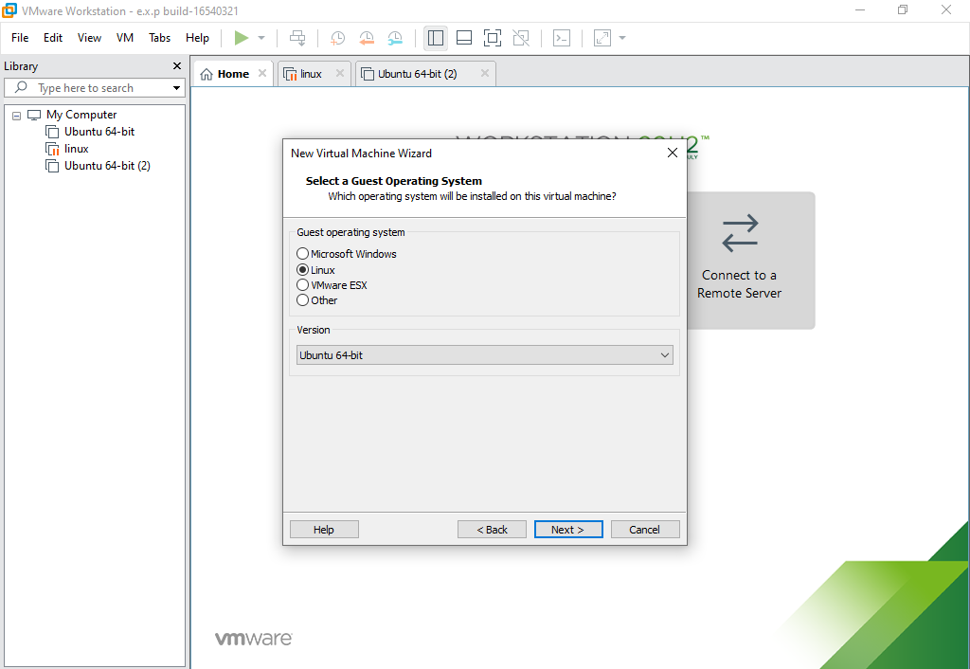

STEP 4: CHOOSE VIRTUAL MACHINE NAME AND LOCATION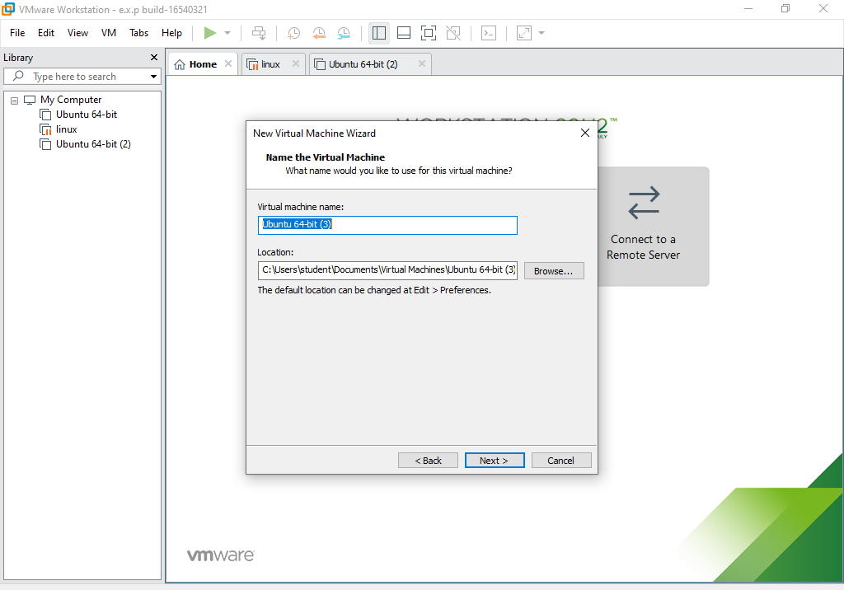STEP 5: MAXIMUM DISK SIZE IS 20 GB AND STORE AS A SINGLE FILE

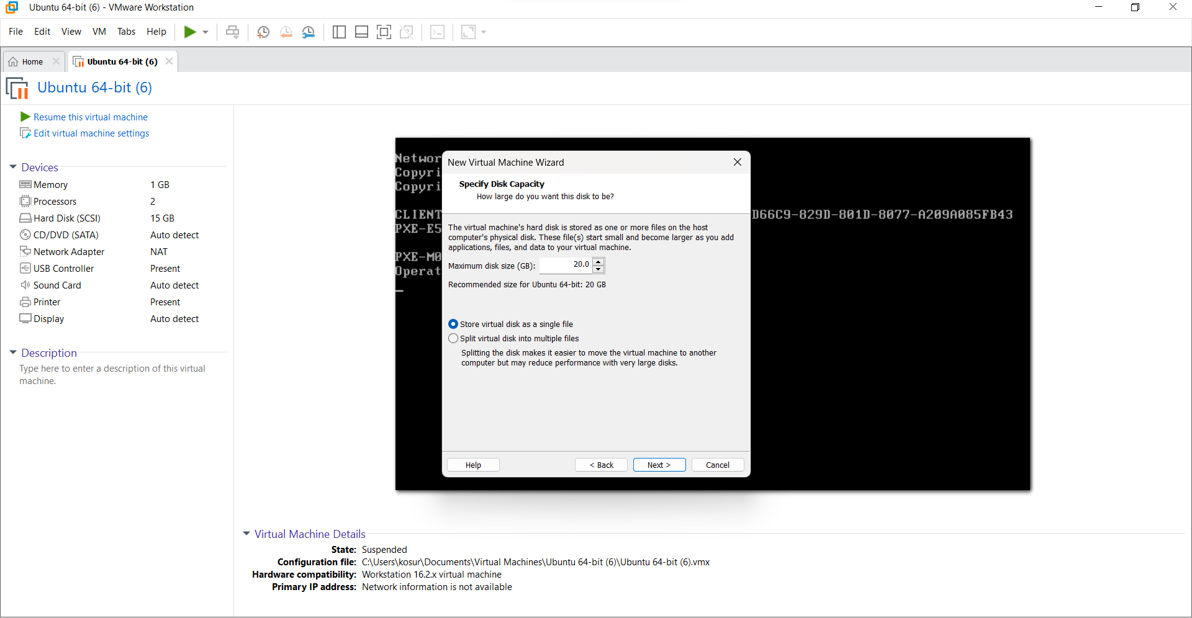

STEP 6: SET HARD DISK SIZE AS 20GB AND MEMORY AS 1GB

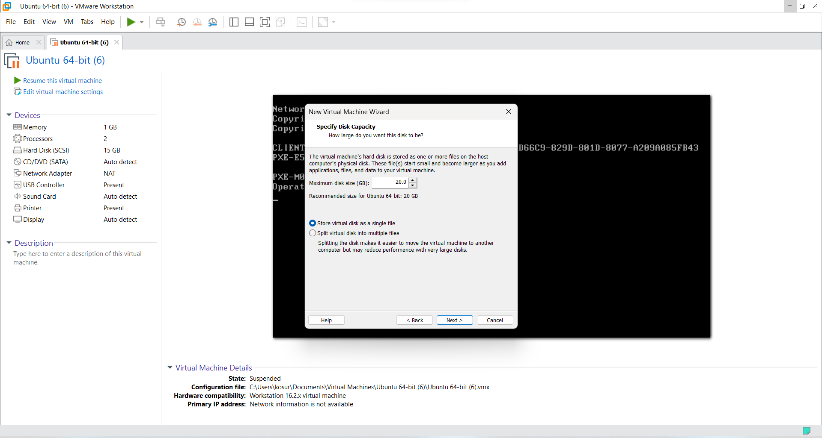

STEP 7:OUTPUT

